**Marketing & Automation**

**Services Pricing**

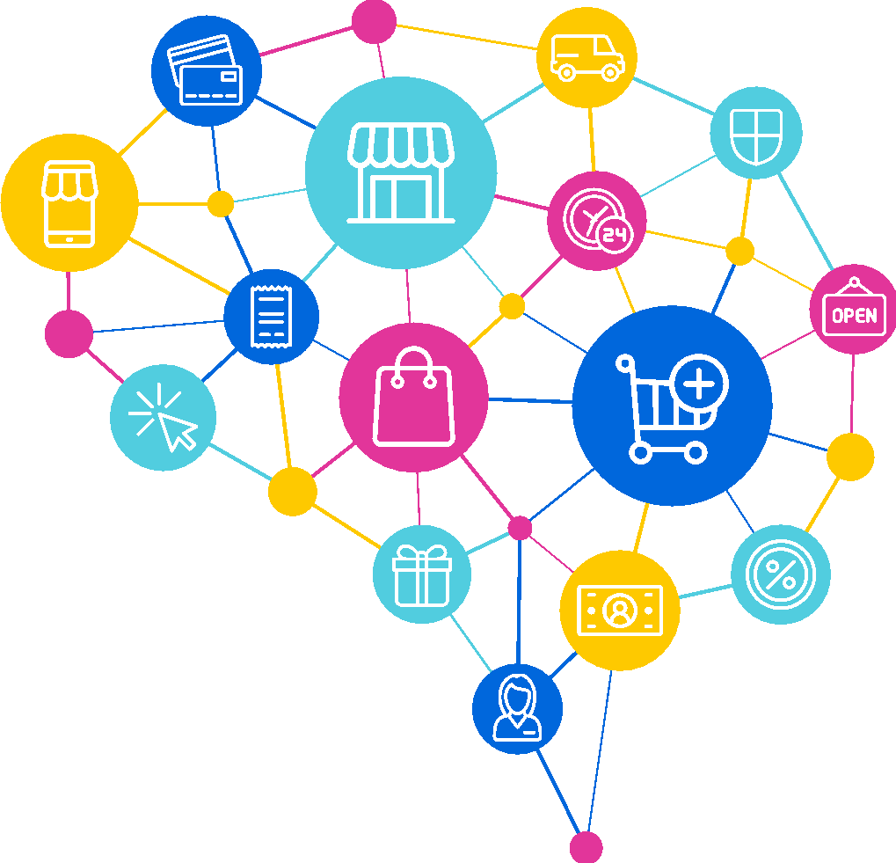

**Design, Build & Scale with AppSynergies**

**Prepared by: AppSynergies**

**14/10/2024**

Appsynergies is a fast-growing SaaS-based Start-Up with a very talented and rapidly expanding team. We develop cutting-edge AI-Driven Applications. We put the value at the heart of our process & focus on What’s important to our users. This way, we can prove the value of our App Idea before we begin development. We then build on this mobile through discovery, design, development & Optimization.

Our Vision is to be one of the leading tech companies in the world, admired for its innovative apps thereby contributing to a better & sustainable world.

Our Core Values: Innovation, Integrity, Quality, Trust, Focus on Consumers, Teamwork, Sustainable Growth, Diversity & Inclusion

|  |  |  |  |  |
| --- | --- | --- | --- | --- |
| **Details** | **Name** | **Designation** | **Contact No** | **Email id** |
| Project Sponsor/Client’s Detail | <<Client Name>> | <<Client Designation>> | <<Client Contact>> | <<Client Email>> |
| Appsynergies Founder | Ishan Soni | CEO & Founder |  | [ishan@appsynergies.co](mailto:ishan@appsynergies.co)m |
| Appsynergies SPOC | Sneha Shukla | HR & Legal Head |  | [info@appsynergies.co](mailto:info@appsynergies.co)m |
| Technical  SPOC | Hardik Vij | Development Manager | +91-8588099741 | Hardik.vij@appsynergies.com |  |  |  |  |  |
| Technical  SPOC | Mounika D | Digital Marketing | +91-6304 668 422 | mounika.devarapalem@appsynergies.com | Technical  SPOC | Mounika D | Digital Marketing | +91-6304 668 422 | mounika.devarapalem@appsynergies.com |

**Supporting SPOC Details:**

**Mutually Agreed Points by Both the Parties:**

Please specify if any: _________________N/A____________

**Why Choose Us?**

Everyone wants to excel in every aspect of their business, which means they will need to take advantage of the best technological tools available too to gain an edge over their competitors. That’s why **AppSynergies Pvt Ltd** provides a customized solution to maximize efficiency and security, minimize cost, and achieve unique goals. Our expertise, resources, and attention to detail make us the ideal choice to meet client expectations. We’ll bring the following strengths to our work for all of our clients:

* **Best IT professionals Team** *–* Everyone we hire brings a wealth of IT experience to the table. This real-world knowledge gives us a unique perspective on the strategies that work to provide the best possible solutions for our clients.
* **Creates a 100% custom solution for any problem** – Our team provides a 100% unique solution to fit your specific IT needs. We won't design a new infrastructure from scratch; we'll take the system you have now and find cost-effective ways to make it more capable and secure.
* **We take a holistic approach to IT and security** *–* We embrace a collaborative approach to meet your IT needs. That means we’ll work with you to get your input about business goals, special concerns, and how you envision your business in the future. We’ll turn that input into a capable, cost-effective system that can grow with you.

**AppSynergies Consultancy Services:**

* + - App development with Flutter
    - Native Android app development
    - Native iOS app development
    - Website development
    - Mac, Windows & Linux software development
    - UI UX Designs for websites & apps
    - AI ML-related software development
    - Digital Marketing Services

**AI Automations Services:**

* Adding leads from trigger to CRM.
* Make & GoHighLevel Tools
* AI Calling
* ManyChat Automation
* Make or Zapier Automation
* Firefly Meeting Automation
* AI generated Social Media Content & Calendar
* AI Chatbot
* AI Content Generation

**Digital Marketing Services:**

Marketing Strategy:

* Understanding your Business Model, Products/Solutions.
* Clearly defined the Marketing Goals & Objectives
* Who is your Target Audience?
* What is your USP?
* Who are the competitors, On which channels you want to do Marketing?
* Based on the above pointers - we will come up with a detailed plan of action along with the timelines.

Social Media Channels:

* Setting up profiles across all the 4 Platforms (Facebook, Instagram, LinkedIn, Twitter)
* Profile Optimization
  + Upload Cover Images
  + Bio
  + Trending Hashtags as per their business
  + Call to Action
* Integration with Heropost

Creative Posts:

* Content Research as per their business & objectives
* Social Media Captions & Hashtags
* Content Calendar for the entire month
* Design Creatives (10 Posts Per Month)
* Automated Timeline Posting

Ad Account Setup:

* Identify the best platform to run Ads as per your business & Target Audience
* Setting up your Ad Account with all details
* Business Verification of your Ad accounts
* Integrate Payment Details

Paid Ads (Lead Generation)

* Define the right Campaign Objectives
* Conversion & Performance Goals
* Allocate Budgets & Timeline to run Ads
* Define the Target Audience (Interests & Behaviour)
* Identify the right placements (Facebook, Instagram)
* Prepare Ad Creatives by our Design Teams
* Update Primary Text, Headlines, Descriptions, CTA’s
* Create a Destination Form to capture Leads
* Track the Events that are happening on your Website via Events Manager.
* Monitor the Ads Performance and optimize campaigns.

Monthly Maintenance & Reporting:

* Briefly summarize key findings and overall performance for the reporting period.
* Highlight successes or areas needing improvement.
* Ad Performance:
  + Reach & Impressions
  + Engagement
  + No of Leads
  + Cost Per Lead
* Audience Insights
* Key Learnings & Recommendations
* Outline the Next Action Items based on your recommendations.

|  |  |  |  |  |
| --- | --- | --- | --- | --- |
| **Name** | **Description** | **Pricing** | **Timeline** | **Type** |
| Landing page website (design + development) | Using Next JS | £200 | 5-10 Days | One Time Fees |
| AI Automations (6 Scenarios) | Leads Connection With CRM & AI Voice Calling Automation | £1000 | 10-20 Days | One Time Fee |
| Whatsapp Automation + Whatsapp Cloud Business Account Setup | Automation Setup | £750 | 10-20 Days | One Time Fee |
| CRM Setup | Any CRM | £500 | 5-10 Days | One Time Fees |
| Email Marketing Setup | Email Templates & Marketing Id | £500 | 5-10 Days | One Time Fees |
| Make/Zapier Automation | Automation Setup | £750 | 10-20 Days | One Time Fee |
| Firefly Meeting Automation | Automation Setup | £250 | 10-20 Days | One Time Fee |
| AI Chatbot | AI-ML Model Training | £500 | 10-20 Days | One Time Fee |
| PDF Generation Automations | PDF Generator Chatbot Automation + 3 PDF Templates | £500 | 10-20 Days | One Time Fee |
| AI generated Social Media Content & Calendar | AI-ML Model Training | £750 | 10-20 Days | One Time Fee |
| Custom AI Models & Agents | AI-ML Model Training | £1000 | 10-20 Days | One Time Fee |
| Marketing Strategy | Research & Plan  Timelines | £300 | 5-7 Days | One Time Fee |
| Social Media Channels | Optimisation, Integration with Heropost For Automated Posting & Hashtags Research | £300 | 5-7 Days | One Time Fee |
| Creatives (10 Per Month) | Content Calendar, Creatives, Research | £200 | 5-7 Days | Monthly Recurring Fee |
| Creatives (20 Per Month) | Content Calendar, Creatives, Research | £350 | 7-10 Days | Monthly Recurring Fee |
| Creatives (30 Per Month) | Content Calendar, Creatives, Research | £500 | 10-14 Days | Monthly Recurring Fee |
| Reels (10 Reels) | Ai Generated Videos / Theme Based / Slide Shows / Animated | £500 | 20-30 Days | Monthly Recurring Fee |
| Meta Ad Account Setup & Pages Setup | Facebook + Instagram | £200 | 2-3 Days | One Time Fee |
| Paid Ads (Lead Generation) | Admin cost to run & manage ads (A/B Testing) – for 5 ads | £300 | 30 Days | Monthly Recurring Fee |
| Monthly Maintenance & Reporting | Social Media Channels, Ad Account (Meta), Sales Accounts – for 5 ads | £200 | 30 Days | Monthly Recurring Fee |

**Next Steps:**

To take advantage of this proposal and proceed with the project as outlined, Next steps must be to:

* Discuss desired changes with AppSynergies Pvt Ltd
* Finalize and sign the contract
* Submit an initial payment

Once completed, AppSynergies Pvt Ltd will contact you to schedule a project launch meeting to make introductions and gather information before beginning the work.

We’re happy to make changes to the project scope on your request at any time but this may be subject to additional billing.

**Feel free to reach out to us at** [**info@appsynergies.com**](mailto:info@appsynergies.com) **or +91-9967067419 for any questions.**

**We look forward to doing business with you.**

**Thank You, Team AppSynergies**